**Contents**

**1. Introduction…………………………………………………………………………………………………………………………..2**

**1.1Purpose…………………………………………………………………………………………………………………………….3**

**1.2 Scope……………………………………………………………………………………………………………………………….4**

**1.3 Application details……………………………………………………………………………………………………………5**

**2. Test strategy………………………………………………………………………………………………………………………….6**

**2.1 testing approach……………………………………………………………………………………………………………….7**

**3. Test environment & Data details………………………………………………………………………………………………**

**3.1 Data source……………………………………………………………………………………………………………………….**

**3.1.1 source dataset details………………………………………………………………………………………………….**

**3.2 Target/Final Tables…………………………………………………………………………………………………………..**

**4. Test case and Scenarios………………………………………………………………………………………………………….**

**4.1 target table compare………………………………………………………………………………………………………….**

**4.1.1 Data type……………………………………………………………………………………………………………………**

**4.1.2 Data count……………………………………………………………………………………………………………………..**

**4.1.3 Data sample………………………………………………………………………………………………………………..**

**Document overview details:**

|  |  |  |
| --- | --- | --- |
| **Content** | **details** | **comment** |
| **Project name** | **F&A TWBI Modernization** |  |
| **Application name** | **Transfix_MD** |  |
| **Document version** | **1.0** |  |
| **Prepared by** | **Kouluri Siva Koteswara Rao** |  |
| **Review by** |  |  |
| **date** |  |  |

1. **Introduction**
   1. **Purpose:**

This document explains how we are testing the updated Transfix_MD after moving from ADF pipelines to Databricks jobs. We aim to make sure everything works properly, meets business needs, and keeps the data accurate.

**1.2 Scope**

* Checking that Databricks jobs do the same work as the old ADF pipelines.
* Making sure data changes, movements, and links are correct.
* Testing speed and fixing any errors that happen.
* Ensuring the final data matches exactly what is expected in production.

**1.3 Application details**

|  |  |
| --- | --- |
| **Test environment** | **dev** |
| ADF resource name | ADF-productsupply-p203 |
| pipelines | Master pipeline:  Child pipeline: |
| Databricks workspace name | dbrproductsupplyn101 |
| Databricks job details | [pg_tw_fa_Transfix] - MD |

# 

# 2.Test Strategy

## 2.1 Testing Approach

|  |  |  |
| --- | --- | --- |
| Test | Details | Status |
| Unit Tests | Validate individual notebook scripts and their transformations. | Check |
| Data Integrity Checks | Compare source and target datasets for correctness. | Check |
| Performance Testing | Compare execution time and resource consumption. | Check |
| Error Handling Tests | Ensure proper logging and error messages for failures. | Check |

# Test Environment & Data details:

## Data Source

### Source dataset details

|  |  |  |
| --- | --- | --- |
| Schema name | Table name | Table/file type |
| cdl_ps_prod.silver_sap_h1p_104 | ZTXXPT0104 ZTXXPT0103 MARM ZTXXPTMELF ZTXXPTATVA ZTXXPTCPIK CABN AUSP KSSK KSML KLAH ZTXX_PTWFREQ ZTXX_PTWFCONFIG ZTXXPTNASS MARA MAKT | unity catalog-delta tables |
| cdl_ps_prod.silver_sap_n6p | tvko_organizational_unit_sales_organizations t001_company_codes lfa1_vendor_master_general_section lfb1_vendor_master_company_code plant_dim t001k_valuation_area kna1_general_data_in_customer_master adr6_e_mail_addresses_business_address_services | unity catalog-views |
| cdl_ps_prod.bronze_rds | cust_hier_dim | unity catalog-delta table |

## Target/ Final Tables

### Target datasets

|  |  |  |
| --- | --- | --- |
| **Catalog/Schema used [catalog-name.schema-name.table-name]** | **Data Environment, Location** | **Description** |
| cdl_ps_dev.silver_ps_transfix_na | Dev, Unity Catalog | Development Schema for Modernized Transfix |
| cdl_ps_prod.silver_transfix_tv_na | Prod, Unity Catalog | Prod Transfix Schema |

**Transfix_MD target tables:**

|  |
| --- |
| cust_hierarchy656_na_lkp |
| cust_na_dim |
| plant_na_dim |
| prod1_na_dim |
| sales_org_na_dim |
| vendor_na_dim |

# Test cases and Scenarios

## Target table Compare:

### 4.1.1 Data Type: Comparing the schema of Prod data to Modernized Dev data

1. Schema Check between cdl_ps_dev.silver_ps_transfix_na and cdl_ps_prod.silver_transfix_tv_na for the Transfix_MD Tables

**Data Type: Comparing the schema of Prod data to Modernized Dev data**

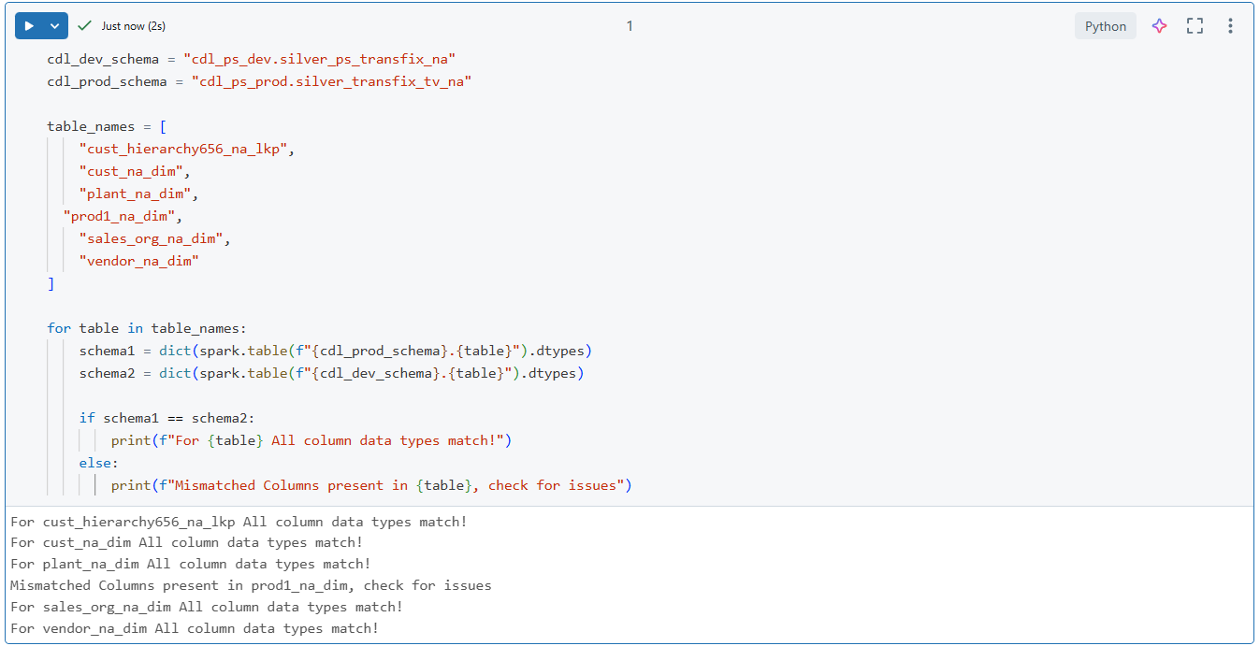

**Data Count: Comparing the Prod data to Modernized Dev data**

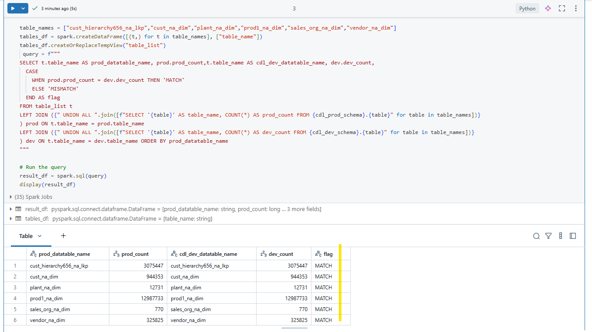

|  |  |
| --- | --- |
| **cust_hierarchy656_na_lkp** | |
| **cdl_ps_dev.silver_ps_transfix_na** | **cdl_ps_prod.silver_transfix_tv_na** |
| customer_id:string | customer_id:string |
| l1_global_lvl:string | l1_global_lvl:string |
| l1_global_name:string | l1_global_name:string |
| l2_key_customer_group_lvl:string | l2_key_customer_group_lvl:string |
| l2_key_customer_group_name:string | l2_key_customer_group_name:string |
| l3_vary1_lvl:string | l3_vary1_lvl:string |
| l3_vary1_name:string | l3_vary1_name:string |
| l4_vary2_lvl:string | l4_vary2_lvl:string |
| l4_vary2_name:string | l4_vary2_name:string |
| l5_country_top_account_lvl:string | l5_country_top_account_lvl:string |
| l5_country_top_account_name:string | l5_country_top_account_name:string |
| l6_vary6_lvl:string | l6_vary6_lvl:string |
| l6_vary6_name:string | l6_vary6_name:string |
| l7_intrmdt_lvl:string | l7_intrmdt_lvl:string |
| l7_intrmdt_name:string | l7_intrmdt_name:string |
| l8_intrmdt2_lvl:string | l8_intrmdt2_lvl:string |
| l8_intrmdt2_name:string | l8_intrmdt2_name:string |
| l9_intrmdt3_lvl:string | l9_intrmdt3_lvl:string |
| l9_intrmdt3_name:string | l9_intrmdt3_name:string |
| l10_intrmdt4_lvl:string | l10_intrmdt4_lvl:string |
| l10_intrmdt4_name:string | l10_intrmdt4_name:string |
| l11_intrmdt5_lvl:string | l11_intrmdt5_lvl:string |
| l11_intrmdt5_name:string | l11_intrmdt5_name:string |
| l12_ship_to_lvl:string | l12_ship_to_lvl:string |
| l12_ship_to_name:string | l12_ship_to_name:string |

**Cust_na_dim:**

|  |  |
| --- | --- |
| **cust_na_dim** | |
| **cdl_ps_dev.silver_ps_transfix_na** | **cdl_ps_prod.silver_transfix_tv_na** |
| customer_id:string | customer_id:string |
| customer_account_group_code:string | customer_account_group_code:string |
| address_id:string | address_id:string |
| city_name:string | city_name:string |
| district_name:string | district_name:string |
| country_code:string | country_code:string |
| customer_class_code:string | customer_class_code:string |
| fax_num:string | fax_num:string |
| fiscal_year_variant_code:string | fiscal_year_variant_code:string |
| tax_num3_code:string | tax_num3_code:string |
| one_time_account_flag:string | one_time_account_flag:string |
| industry_code:string | industry_code:string |
| industry2_code:string | industry2_code:string |
| industry3_code:string | industry3_code:string |
| industry4_code:string | industry4_code:string |
| industry5_code:string | industry5_code:string |
| lang_code:string | lang_code:string |
| customer1_name:string | customer1_name:string |
| customer2_name:string | customer2_name:string |
| customer3_name:string | customer3_name:string |
| nielsen_id:string | nielsen_id:string |
| trade_partner_company_id:string | trade_partner_company_id:string |
| first_phone_num:string | first_phone_num:string |
| plant_code:string | plant_code:string |
| po_box_num:string | po_box_num:string |
| postal_code_num:string | postal_code_num:string |
| po_box_postal_code_num:string | po_box_postal_code_num:string |
| region_code:string | region_code:string |
| sort_field_name:string | sort_field_name:string |
| house_num_and_street_name:string | house_num_and_street_name:string |
| tax1_num:string | tax1_num:string |
| tax2_num:string | tax2_num:string |
| usage_code:string | usage_code:string |
| vendor_or_creditor_account_num:string | vendor_or_creditor_account_num:string |
| authrz_group_code:string | authrz_group_code:string |
| customer_central_dlvry_block_code:string | customer_central_dlvry_block_code:string |
| county_code:string | county_code:string |
| sales_figure_currency_code:string | sales_figure_currency_code:string |
| master_record_delete_flag:string | master_record_delete_flag:string |
| first_fax_num:string | first_fax_num:string |
| title1_name | title1_name:string |
| legal_status_code:string | legal_status_code:string |
| customer_short_name:string | customer_short_name:string |
| payment_block_code:string | payment_block_code:string |
| tax_jrsdct_code:string | tax_jrsdct_code:string |
| central_order_block_code:string | central_order_block_code:string |
| express_train_station_name:string | express_train_station_name:string |
| train_station_name:string | train_station_name:string |
| intl_loc1_num:string | intl_loc1_num:string |
| intl_loc2_num:string | intl_loc2_num:string |
| intl_loc_check_digit_num:string | intl_loc_check_digit_num:string |
| central_sales_block_flag:string | central_sales_block_flag:string |
| biochemical_warfare_flag:string | biochemical_warfare_flag:string |
| nuclear_prevent_flag:string | nuclear_prevent_flag:string |
| national_security_flag:string | national_security_flag:string |
| missile_tech_flag:string | missile_tech_flag:string |
| customer_fiscal_code:string | customer_fiscal_code:string |
| non_military_use_flag:string | non_military_use_flag:string |
| data_comm_line_num:string | data_comm_line_num:string |
| compttr_flag:string | compttr_flag:string |
| sales_partner_flag:string | sales_partner_flag:string |
| sales_prospect_flag:string | sales_prospect_flag:string |
| customer_type4_flag:string | customer_type4_flag:string |
| default_sold_to_party_id:string | default_sold_to_party_id:string |
| consumer_flag:string | consumer_flag:string |
| data_medium_exchange_flag:string | data_medium_exchange_flag:string |
| data_transfer_into_subseq_release_code:string | data_transfer_into_subseq_release_code:string |
| initial_contact_flag:string | initial_contact_flag:string |
| record_create_date:string | record_create_date:string |
| object_create_name:string | object_create_name:string |
| customer_plant_group_flag:string | customer_plant_group_flag:string |
| unload_point_exist_flag:string | unload_point_exist_flag:string |
| central_billing_block_for_customer_code:string | central_billing_block_for_customer_code:string |
| master_fiscal_address_account_num:string | master_fiscal_address_account_num:string |
| assign_to_hier_id:string | assign_to_hier_id:string |
| inspect_for_dlvry_note_after_outbound_dlvry_flag:string | inspect_for_dlvry_note_after_outbound_dlvry_flag:string |
| inspect_carry_out_by_customer_flag:string | inspect_carry_out_by_customer_flag:string |
| employee_year_num:string | employee_year_num:string |
| year_employee_cnt:string | year_employee_cnt:string |
| customer_attr1_code:string | customer_attr1_code:string |
| customer_attr10_code:string | customer_attr10_code:string |
| customer_attr2_code:string | customer_attr2_code:string |
| customer_attr3_code:string | customer_attr3_code:string |
| customer_attr4_code:string | customer_attr4_code:string |
| customer_attr5_code:string | customer_attr5_code:string |
| customer_attr6_code:string | customer_attr6_code:string |
| customer_attr7_code:string | customer_attr7_code:string |
| customer_attr8_code:string | customer_attr8_code:string |
| customer_attr9_code:string | customer_attr9_code:string |
| customer_cond_group1_code:string | customer_cond_group1_code:string |
| customer_cond_group2_code:string | customer_cond_group2_code:string |
| customer_cond_group3_code:string | customer_cond_group3_code:string |
| customer_cond_group4_code:string | customer_cond_group4_code:string |
| customer_cond_group5_code:string | customer_cond_group5_code:string |
| work_time_cal_name:string | work_time_cal_name:string |
| alt_payer_account_num:string | alt_payer_account_num:string |
| uniform_resource_code:string | uniform_resource_code:string |
| one_time_account_ref_group_code:string | one_time_account_ref_group_code:string |
| trans_zone_code:string | trans_zone_code:string |
| search_term1_name:string | search_term1_name:string |
| search_term_name:string | search_term_name:string |
| search_term2_name:string | search_term2_name:string |
| main_military_use_id:string | main_military_use_id:string |
| central_posting_block_flag:string | central_posting_block_flag:string |
| tax4_num:string | tax4_num:string |
| tax_num_type_code:string | tax_num_type_code:string |
| equalzn_tax_bus_partner_subject_flag:string | equalzn_tax_bus_partner_subject_flag:string |
| natural_person_flag:string | natural_person_flag:string |
| liable_for_vat_flag:string | liable_for_vat_flag:string |
| telebox_num:string | telebox_num:string |
| second_phone_num:string | second_phone_num:string |
| teletex_num:string | teletex_num:string |
| sales_year_num:string | sales_year_num:string |
| annual_sales1_amt:decimal(8,2) | annual_sales1_amt DECIMAL(8,2) |
| annual_sales2_amt:decimal(15,2) | annual_sales2_amt DECIMAL(15,2) |
| icms_exempt_customer_flag:string | icms_exempt_customer_flag:string |
| alt_payer_using_account_num_flag:string | alt_payer_using_account_num_flag:string |
| customer_group_for_tax_substtn_calc_code:string | customer_group_for_tax_substtn_calc_code:string |
| indstrl_prod_tax_exempt_customer_flag:string | indstrl_prod_tax_exempt_customer_flag:string |
| alt_payer_allow_in_doc_flag:string | alt_payer_allow_in_doc_flag:string |
| group_key_code:string | group_key_code:string |
| telex_num:string | telex_num:string |
| data_medium_exchange_instr_code:string | data_medium_exchange_instr_code:string |
| state_vat_law_val:string | state_vat_law_val:string |
| indstrl_prod_tax_law_val:string | indstrl_prod_tax_law_val:string |
| city_code:string | city_code:string |
| city_coord_val:string | city_coord_val:string |
| po_box_city_name:string | po_box_city_name:string |
| regional_market_name:string | regional_market_name:string |
| vat_registn_num:string | vat_registn_num:string |
| tax_code:string | tax_code:string |
| email_address_name:string | email_address_name:string |
| corp_group_name:string | corp_group_name:string |
| customer_team_code:string | customer_team_code:string |
| corporate_group_name:string | corporate_group_name:string |
| distrib_channel_code:string | distrib_channel_code:string |

**Plant_na_dim:**

|  |  |
| --- | --- |
| **plant_na_dim** | |
| **cdl_ps_dev.silver_ps_transfix_na** | **cdl_ps_prod.silver_transfix_tv_na** |
| plant_id:string | plant_id:string |
| city_name:string | city_name:string |
| company_code:string | company_code:string |
| country_code:string | country_code:string |
| county_code:string | county_code:string |
| interco_billing_distrib_channel_code:string | interco_billing_distrib_channel_code:string |
| interco_billing_divison_code:string | interco_billing_divison_code:string |
| factory_cal_code:string | factory_cal_code:string |
| vltn_area_num:string | vltn_area_num:string |
| lang_code:string | lang_code:string |
| city_code:string | city_code:string |
| plant_name:string | plant_name:string |
| plant2_name:string | plant2_name:string |
| maint_plan_plant_name:string | maint_plan_plant_name:string |
| plant_categ_code:string | plant_categ_code:string |
| po_box_num:string | po_box_num:string |
| postal_code_num:string | postal_code_num:string |
| purchase_org_name:string | purchase_org_name:string |
| region_code:string | region_code:string |
| customer_num:string | customer_num:string |
| interco_billing_sales_org_num:string | interco_billing_sales_org_num:string |
| sales_district_name:string | sales_district_name:string |
| house_num_and_street_name:string | house_num_and_street_name:string |
| tax_jrsdct_code:string | tax_jrsdct_code:string |
| vendor_plant_num:string | vendor_plant_num:string |
| variance_code:string | variance_code:string |
| actvng_reqmt_plan_flag:string | actvng_reqmt_plan_flag:string |
| po_tolrnc_compress_day_cnt:string, | po_tolrnc_compress_day_cnt:string |
| take_regular_vendor_into_account_flag:string | take_regular_vendor_into_account_flag:string |
| batch_status_mgmt_active_flag:string | batch_status_mgmt_active_flag:string |
| plant_level_cond_flag:string | plant_level_cond_flag:string |
| source_list_reqmt_flag:string | source_list_reqmt_flag:string |
| first_reminder_day_cnt:DECIMAL(3,0) | first_reminder_day_cnt:DECIMAL(3,0) |
| second_reminder_day_cnt:DECIMAL(3,0) | second_reminder_day_cnt:DECIMAL(3,0) |
| third_reminder_day_cnt:DECIMAL(3,0) | third_reminder_day_cnt:DECIMAL(3,0) |
| plant_purchase_tax_flag:string | plant_purchase_tax_flag:string |
| first_dunning_of_vendor_declr_name:string | first_dunning_of_vendor_declr_name:string |
| second_dunning_of_vendor_declr_name:string | second_dunning_of_vendor_declr_name:string |
| third_dunning_of_vendor_declr_name:string | third_dunning_of_vendor_declr_name:string |
| supply_region_name:string | supply_region_name:string |

**Sales_org_na_dim:**

|  |  |
| --- | --- |
| **sales_org_na_dim** | |
| **cdl_ps_dev.silver_ps_transfix_na** | **cdl_ps_prod.silver_transfix_tv_na** |
| sales_org_id:string | sales_org_id:string |
| sales_org_company_code:string | sales_org_company_code:string |
| country_code:string | country_code:string |
| currency_code:string | currency_code:string |
| fiscal_year_variant_code:string | fiscal_year_variant_code:string |
| interco_billing_customer_num:string | interco_billing_customer_num:string |
| stats_currency_code:string | stats_currency_code:string |

**Vendor_na_dim:**

|  |  |
| --- | --- |
| **vendor_na_dim** | |
| **cdl_ps_dev.silver_ps_transfix_na** | **cdl_ps_prod.silver_transfix_tv_na** |
| vendor_account_num:string | vendor_account_num:string |
| vendor_account_group_code:string | vendor_account_group_code:string |
| city_name:string | city_name:string |
| district_name:string | district_name:string |
| country_code:string | country_code:string |
| credit_info_num:string | credit_info_num:string |
| fax_num:string | fax_num:string |
| one_time_account_flag:string | one_time_account_flag:string |
| industry_code:string | industry_code:string |
| lang_code:string | lang_code:string |
| carr1_name:string | carr1_name:string |
| carr2_name:string | carr2_name:string |
| carr3_name:string | carr3_name:string |
| trade_partner_company_id:string | trade_partner_company_id:string |
| first_phone_num:string | first_phone_num:string |
| plant_code:string | plant_code:string |
| po_box_num:string | po_box_num:string |
| postal_code_num:string | postal_code_num:string |
| po_box_postal_code_num:string | po_box_postal_code_num:string |
| region_code:string | region_code:string |
| sort_field_name:string | sort_field_name:string |
| house_num_and_street_name:string | house_num_and_street_name:string |
| tax1_num:string | tax1_num:string |
| tax2_num:string | tax2_num:string |
| master_record_delete_flag:string | master_record_delete_flag:string |
| last_review_date:string | last_review_date:string |
| tax_jrsdct_code:string | tax_jrsdct_code:string |
| train_station_name:string | train_station_name:string |
| intl_loc1_num:string | intl_loc1_num:string |
| intl_loc2_num:string | intl_loc2_num:string |
| intl_loc_check_digit_num:string | intl_loc_check_digit_num:string |
| data_comm_line_num:string | data_comm_line_num:string |
| data_medium_exchange_flag:string | data_medium_exchange_flag:string |
| isr_subscriber_num:string | isr_subscriber_num:string |
| fiscal_address_account_num:string | fiscal_address_account_num:string |
| withhold_tax_person_birth_date:string | withhold_tax_person_birth_date:string |
| withhold_tax_person_birth_place_name:string | withhold_tax_person_birth_place_name:string |
| one_time_account_ref_account_group_name:string | one_time_account_ref_account_group_name:string |
| alt_payee_account_num:string | alt_payee_account_num:string |
| vendor_sub_range_relevant_flag:string | vendor_sub_range_relevant_flag:string |
| search_term1_name:string | search_term1_name:string |
| search_term2_name:string | search_term2_name:string |
| search_term3_name:string | search_term3_name:string |
| factory_cal_code:string | factory_cal_code:string |
| withhold_tax_person_sex_code:string | withhold_tax_person_sex_code:string |
| central_impose_purchase_block_flag:string | central_impose_purchase_block_flag:string |
| block_function_code:string | block_function_code:string |
| central_posting_block_flag:string | central_posting_block_flag:string |
| equalzn_tax_bus_partner_subject_flag:string | equalzn_tax_bus_partner_subject_flag:string |
| natural_person_flag:string | natural_person_flag:string |
| liable_for_vat_flag:string | liable_for_vat_flag:string |
| telebox_num:string | telebox_num:string |
| second_phone_num:string | second_phone_num:string |
| teletex_num:string | teletex_num:string |
| plant_level_relevant_flag:string | plant_level_relevant_flag:string |
| alt_payee_allow_flag:string | alt_payee_allow_flag:string |
| minority_ind_code:string | minority_ind_code:string |
| title1_name:string | title1_name:string |
| data_medium_exchange_instr_code:string | data_medium_exchange_instr_code:string |
| record_create_date:string | record_create_date:string |
| object_create_name:string | object_create_name:string |
| group_code:string | group_code:string |
| customer_num:string | customer_num:string |
| carr4_name:string | carr4_name:string |
| telex_num:string | telex_num:string |
| vat_registn_num:string | vat_registn_num:string |
| po_box_city_name:string | po_box_city_name:string |
| payment_block_code:string | payment_block_code:string |
| std_carr_access_code:string | std_carr_access_code:string |